Mini Project
Contact Centre WFM Analytics
Data Cleaning Steps

Prepared by Ramya | 7 November 2026 | Tools: Microsoft Excel and Power Query Editor

1. Overview
This document records the steps performed to clean the datasets in the Call Volume & Workforce Analytics Dashboard workbook. For every sheet it explains what was wrong with the data, what was done to fix it and why, and includes the screenshot taken while carrying out that step.
Cleaning was done in two places:
- Power Query Editor for changing data types, removing duplicates and errors, trimming and capitalising text, and replacing null values.
- Excel formulas, filters and conditional formatting for profiling the data (MIN / MAX), validating totals and correcting individual values.

2. Call_Volume Sheet
This sheet holds daily call statistics for each skill: calls offered, answered and abandoned, average handle time, average speed of answer and service level.

Step 1: Reviewed the raw data
The table was opened in Excel, The Date column had two formats: most of the values were real dates (for example 2026-07-01) but some had been typed as text in dd/mm/yyyy format (02/07/2026, 08/07/2026, 18/07/2026). These text dates are left-aligned and would not sort or filter as dates.
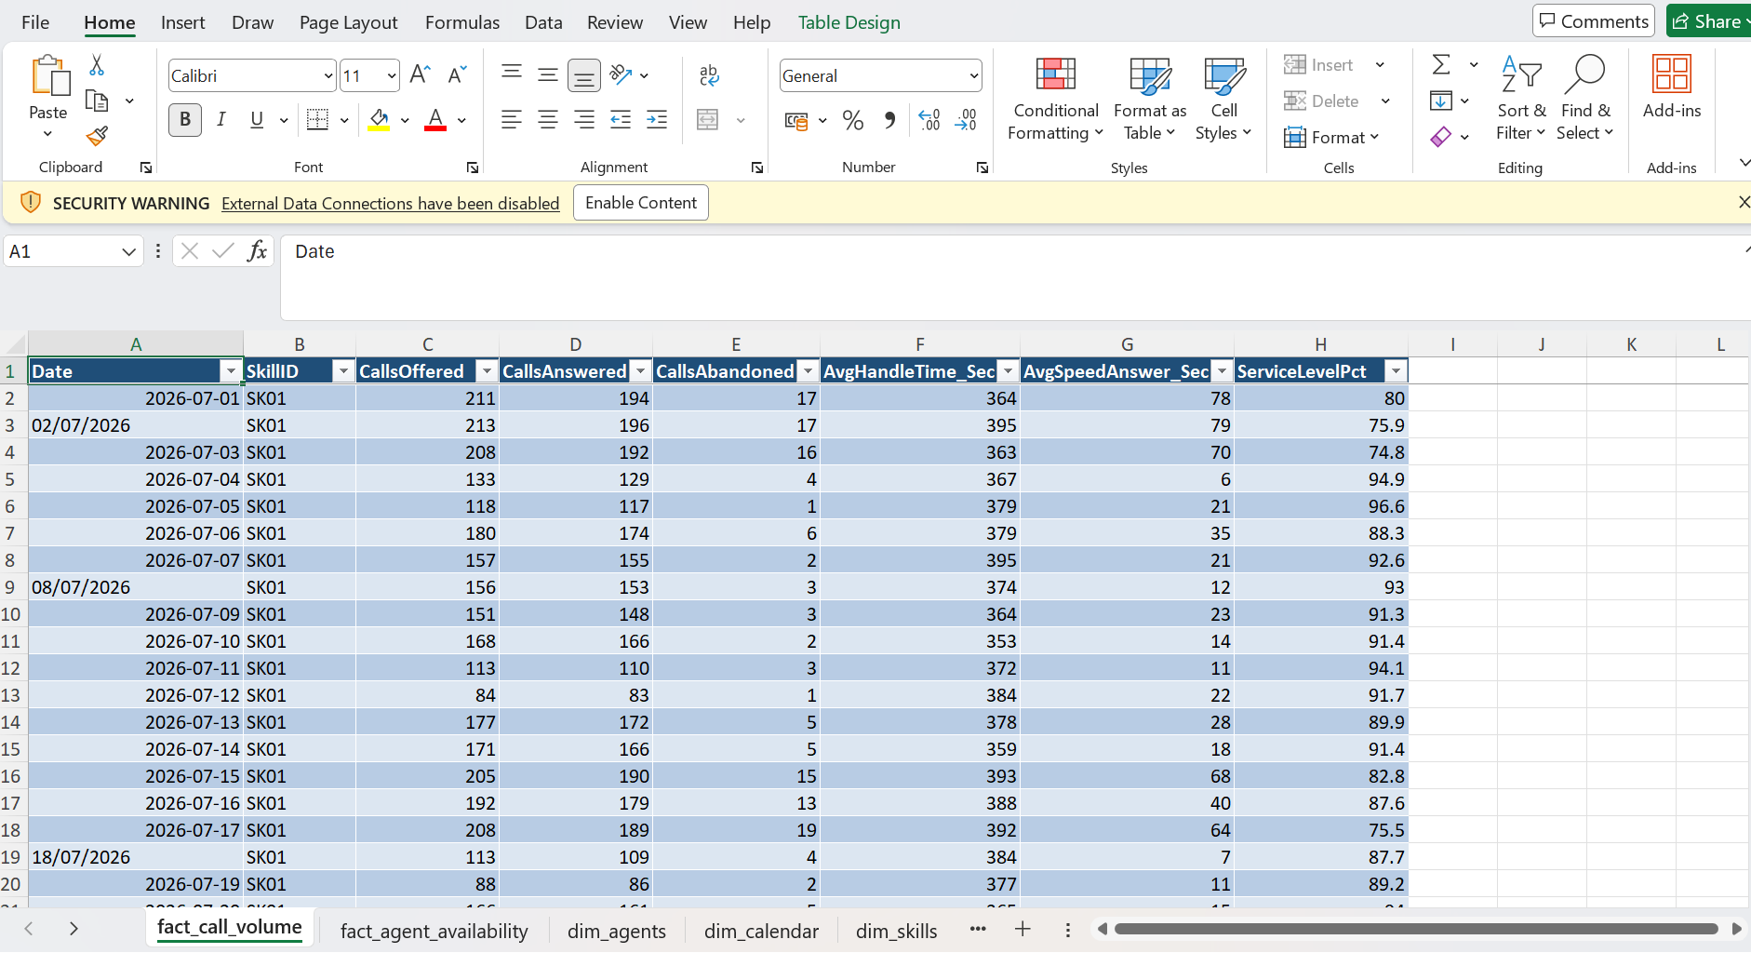

Step 2: Loaded into Power Query and set data types
The table was loaded into Power Query, All columns had the generic "Any" type, so values such as the call counts were not recognised as numbers (some, like 154, appear left-aligned as text). The Date column was changed to the Date type, SkillID to Text and the numeric columns were set to Whole Number.
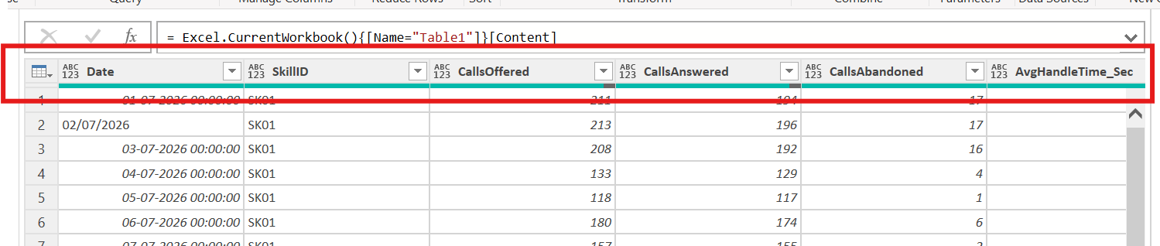

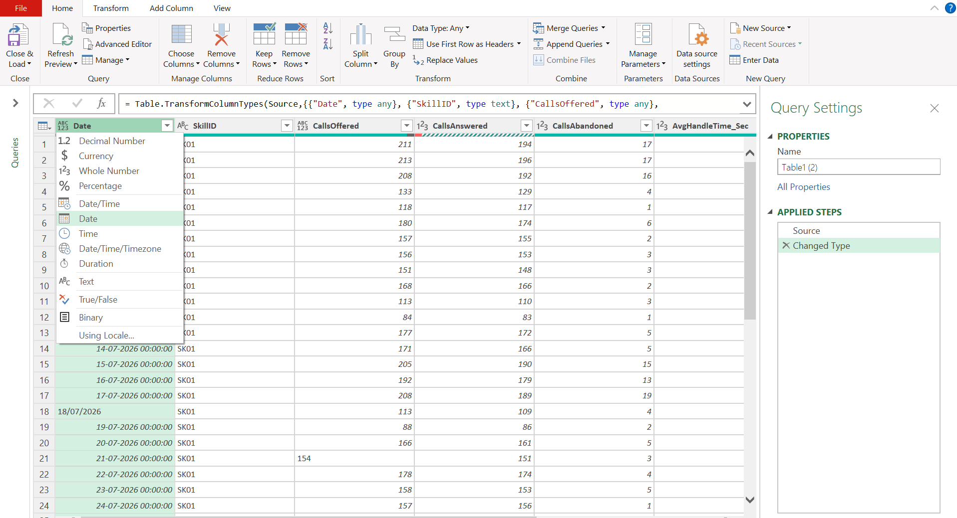

Step 3: Remove duplicate rows
Selected all the columns removed duplicate rows (Home > Remove Rows > Remove Duplicates) so that any repeated record is removed, The preview showed 944 rows and 8 columns before this step; the cleaned Call_Volume sheet reduced to 936 records now.
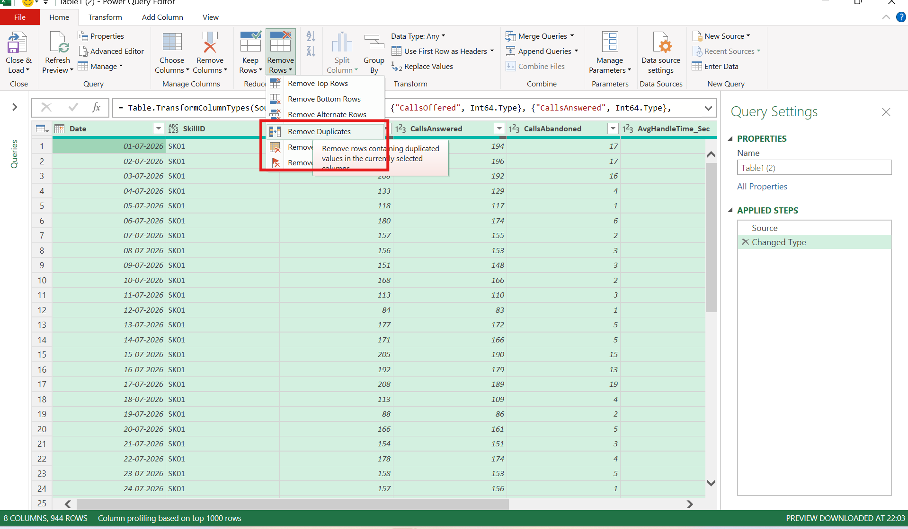

Step 4: Identify invalid handle times
After loading the data back to Excel, AvgHandleTime_Sec contained two negative values, -878 and -572. A handle time cannot be negative, so these entries were treated as data-entry errors and corrected. The cleaned sheet has no negative handle times (the lowest value is 331 seconds).
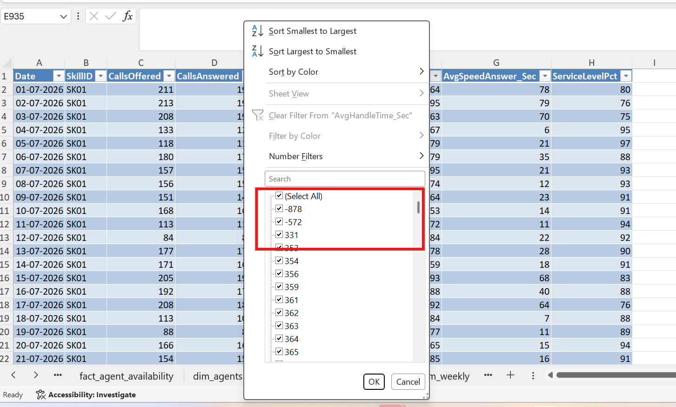

Step 5: Fill missing AvgHandleTime_Sec
Filtering the column for null values showed 8 rows without an average handle time. Null value was filled using performing Median function on the given average handled time values, (Transform > Statistics > Median). The result was 460.5, so the nulls were replaced with 461 using Replace Values.
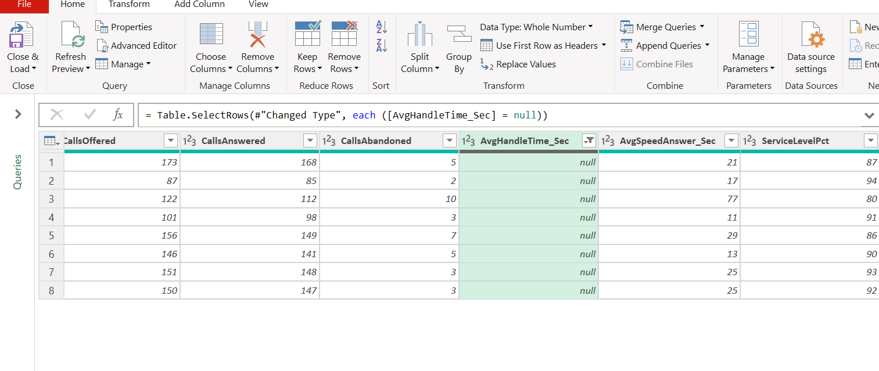
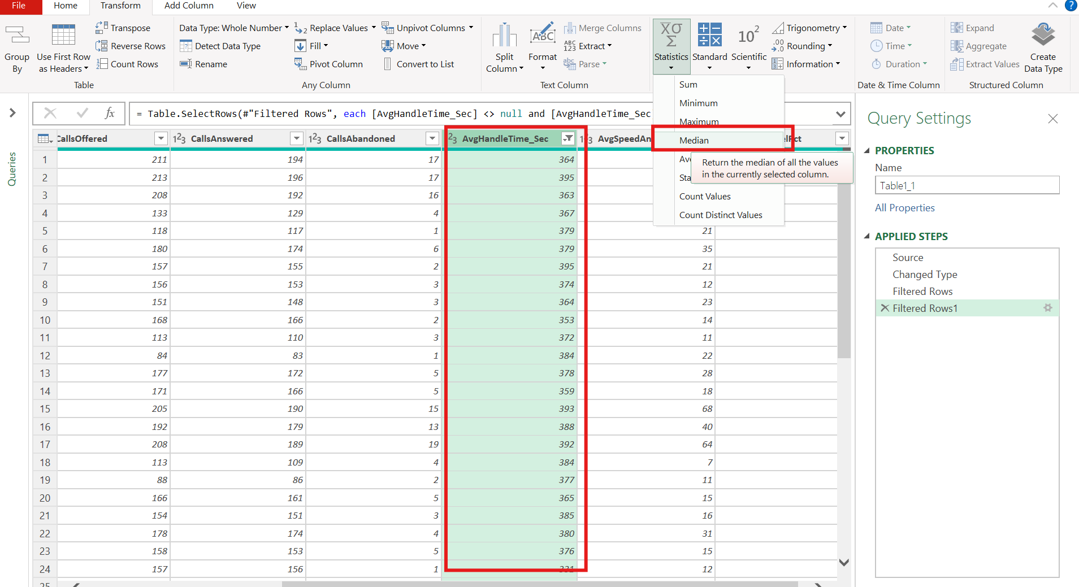
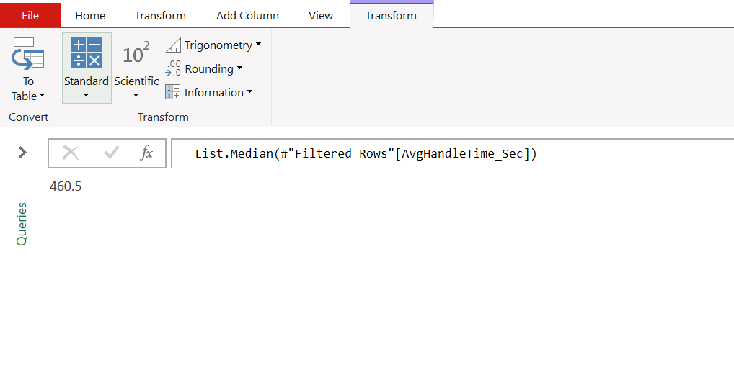
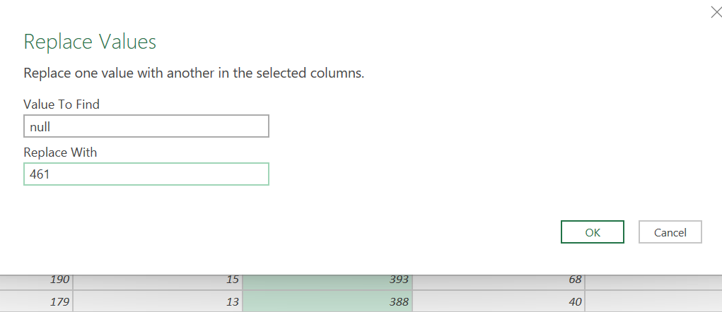

Step 6: Fill missing ServiceLevelPct
One row (98 calls offered, 96 answered, 2 abandoned) had no service level. The average of the column was calculated with Transform > Statistics > Average, giving 90.6, and the null was replaced with 91.
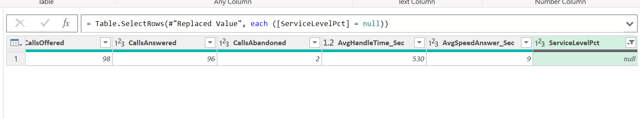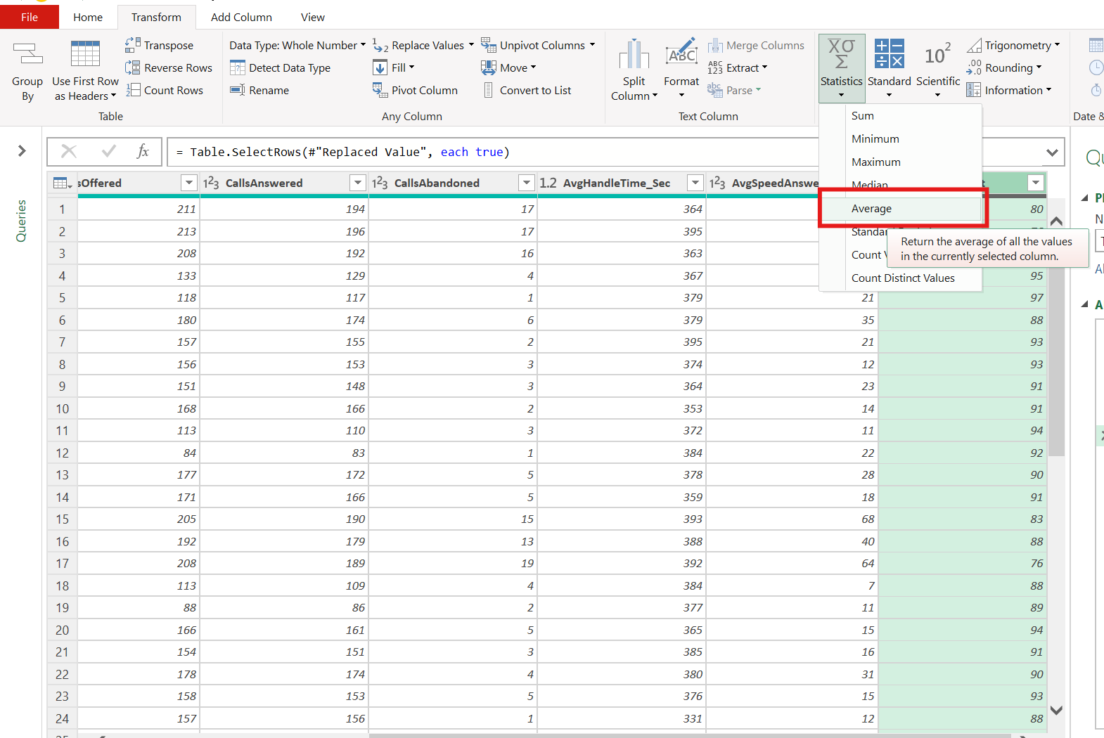
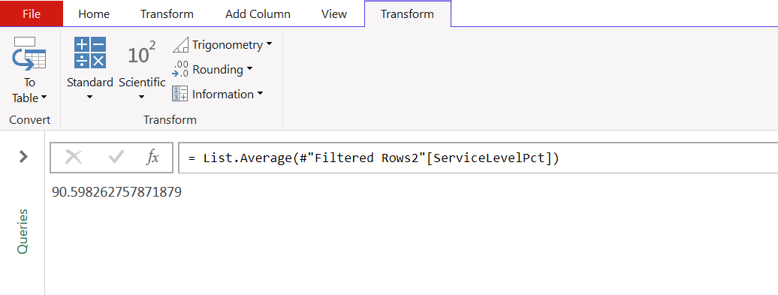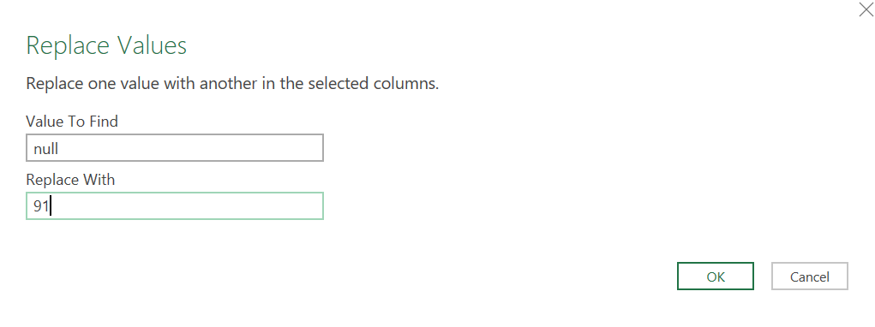

Step 7: Fill missing CallsOffered
Filtering CallsOffered for blanks returned 3 rows (29-08-2026 SK02, 03-09-2026 SK08 and 24-09-2026 SK08). Because offered calls are the sum of answered and abandoned calls, the blanks were filled with the formula =SUM([@CallsAnswered],[@CallsAbandoned]), which gave 108, 159 and 141.
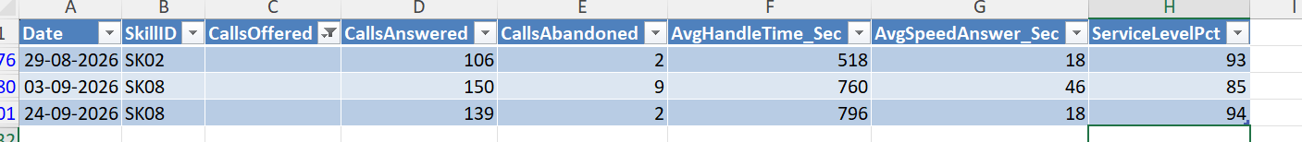
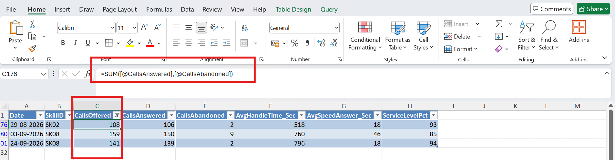

Step 8: Fill missing CallsAnswered
Filtering CallsAnswered for blanks returned 6 blank rows. summing CallsAnswered + CallsAbandoned to get the missing CallsOffered values
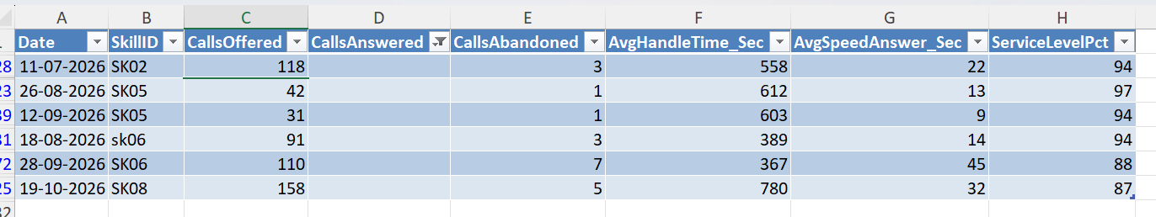

Step 9: Validate CallsOffered against Answered + Abandoned
To check the call offered counts are consistent, adding CallsAnswered and CallsAbandoned, found the actual number of calls offered and using =IF([@CallsOffered]=[@Column1],"Matched","Miss-Matched")
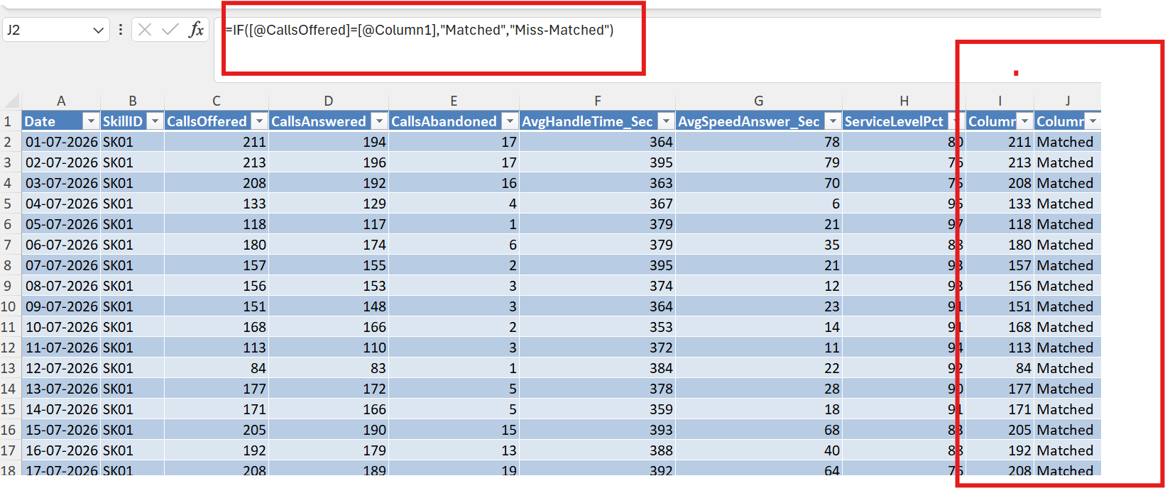
Figure 17: Helper columns: Column1 (Answered + Abandoned) and Column2 (Matched / Miss-Matched check)
Found 5 "Miss-Matched" rows where actual call count was not matching with generated call offering value. (for example 120 offered against 1,190 answered, and 1,240 offered against 121 answered).

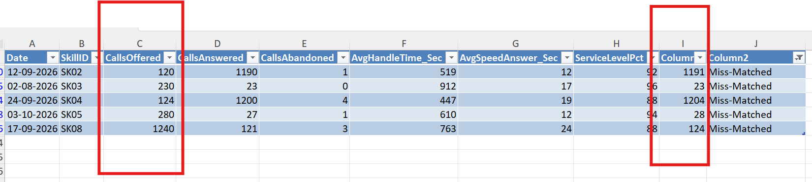

Corrected the callsoffered values as below, considering those values to be miss typed.

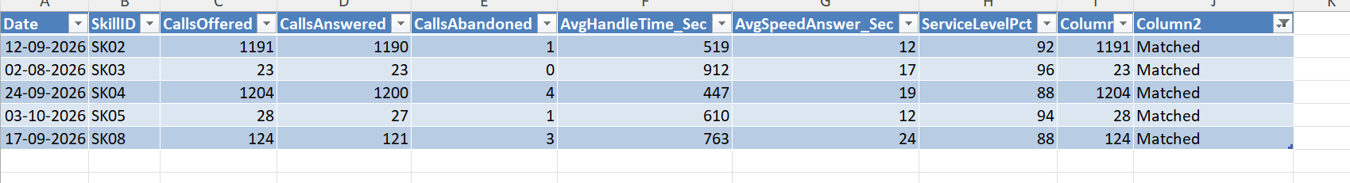

Step 10: Add a Day column and sort
A Day column was added with the formula =TEXT([@Date],"dddd") so that call volume can be analysed by weekday. The table was then sorted by Date from newest to oldest and the dates are shown in dd-mm-yyyy format.
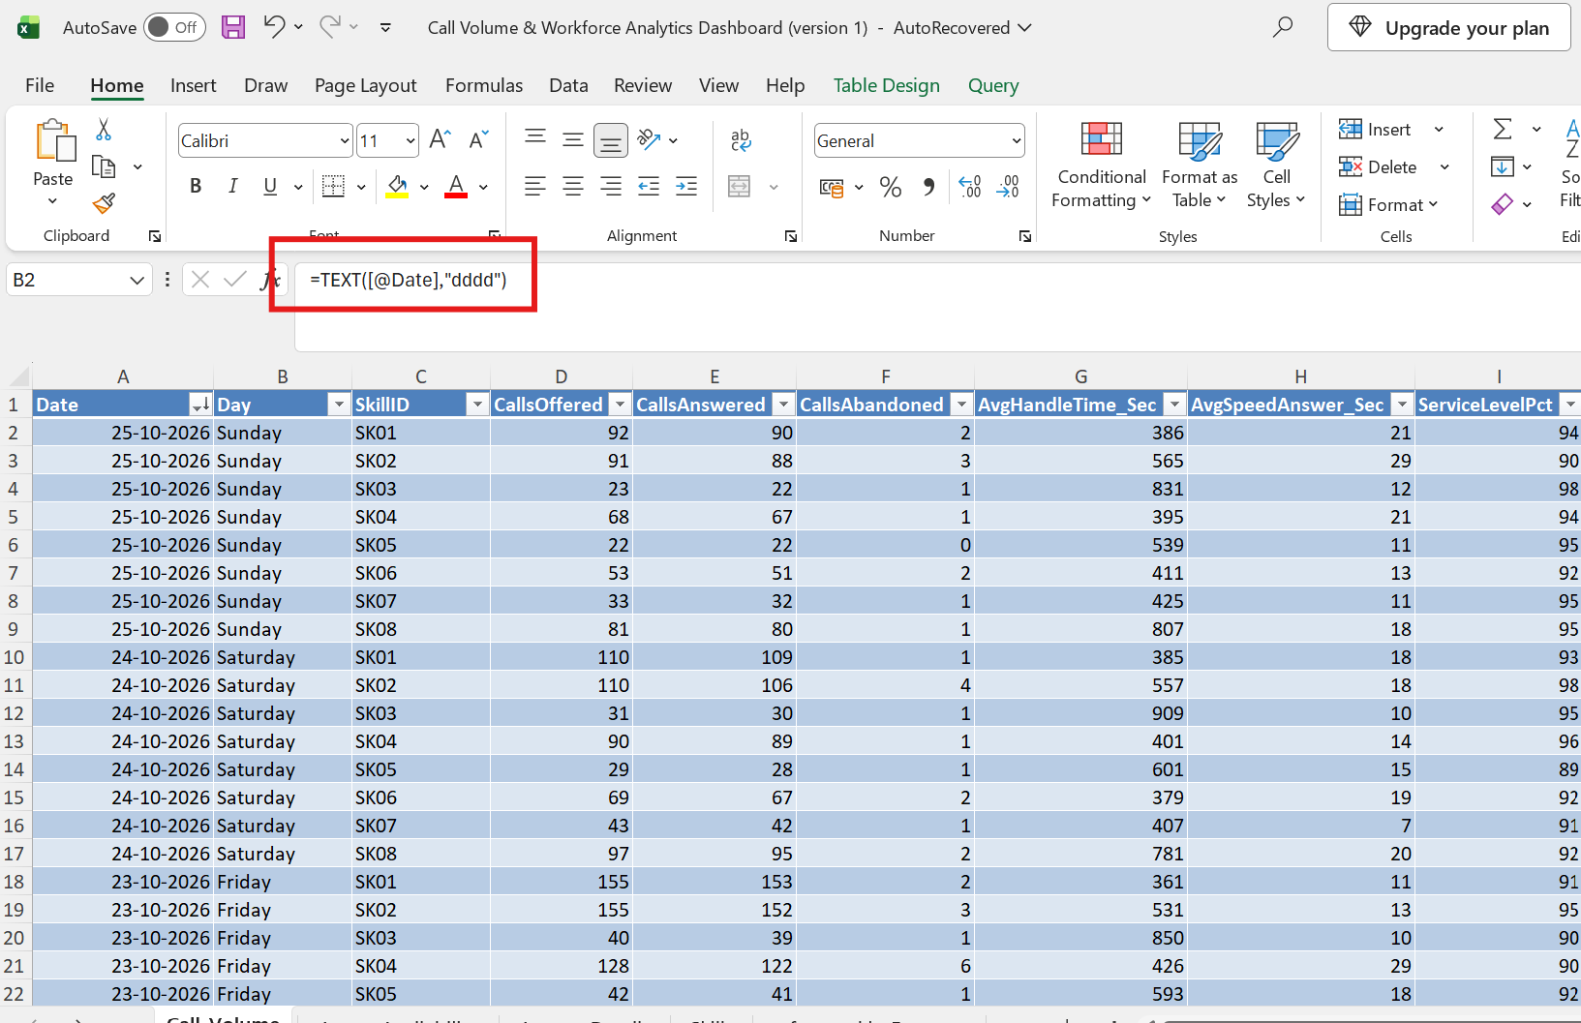

3. Agents_Availability Sheet
This sheet records, the agents logged in, ready, on calls (talk), in after-call work (ACW) and in auxiliary states, plus the number of calls handled time.

Step 1: Profile the data with MIN and MAX
A small "Specs" table was built beside the data. It uses =MAX(D:D), =MIN(D:D) and the same functions for each time column to find the smallest and largest value, and =CONVERT(L2,"min","hr") to show each result in hours. This makes unrealistic values easy to see.
Two results were impossible. The maximum talk time was 2,828 minutes (47.13 hours), and the maximum login time was 5,270 minutes (about 87 hours) for AG1024 on 23-10-2026, in a data set where a shift is about 9 hours.
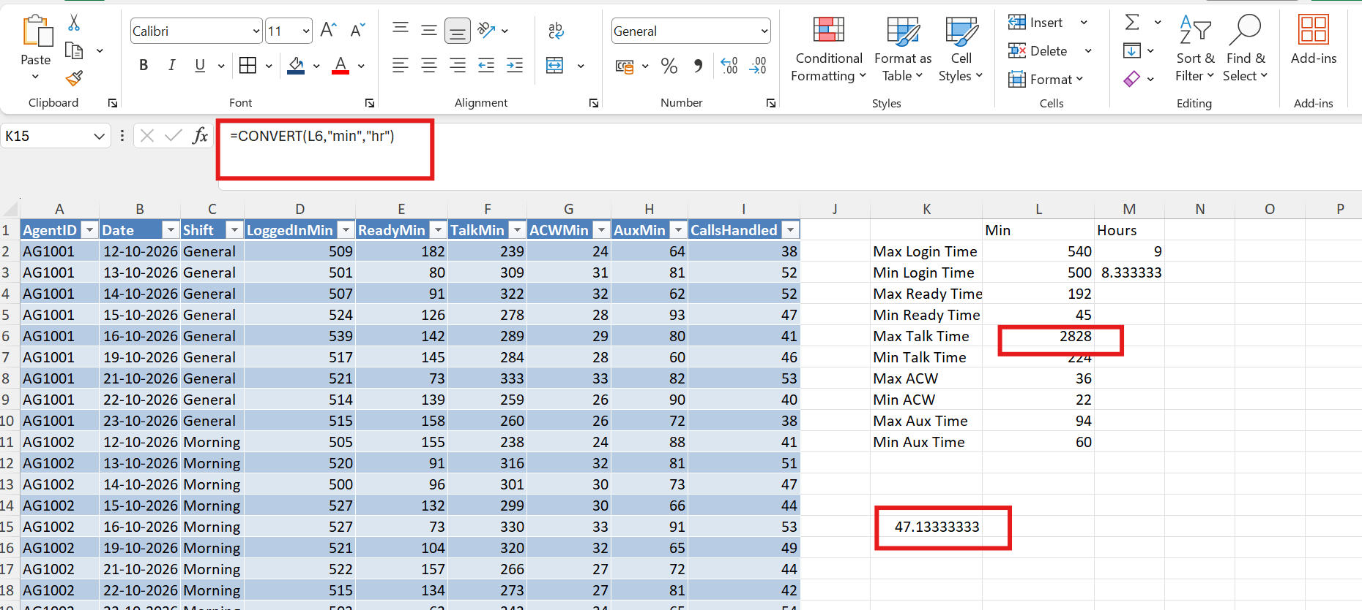
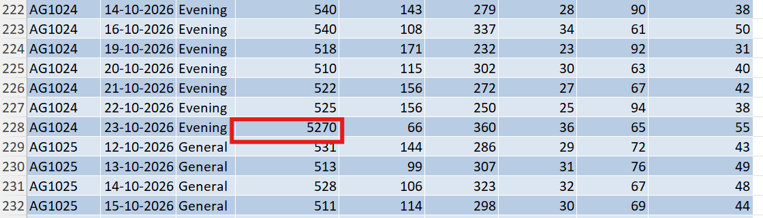
Fix applied: both values were typing errors with an extra digit. LoggedInMin 5270 was corrected to 527 and the maximum TalkMin 2828 to 282. After the correction the Specs table shows a maximum login time of 540 minutes (9 hours) and a maximum talk time of 361 minutes (6.02 hours).
Calculated Min and Max time spend by the agents by using MAX() and MIN() functions.

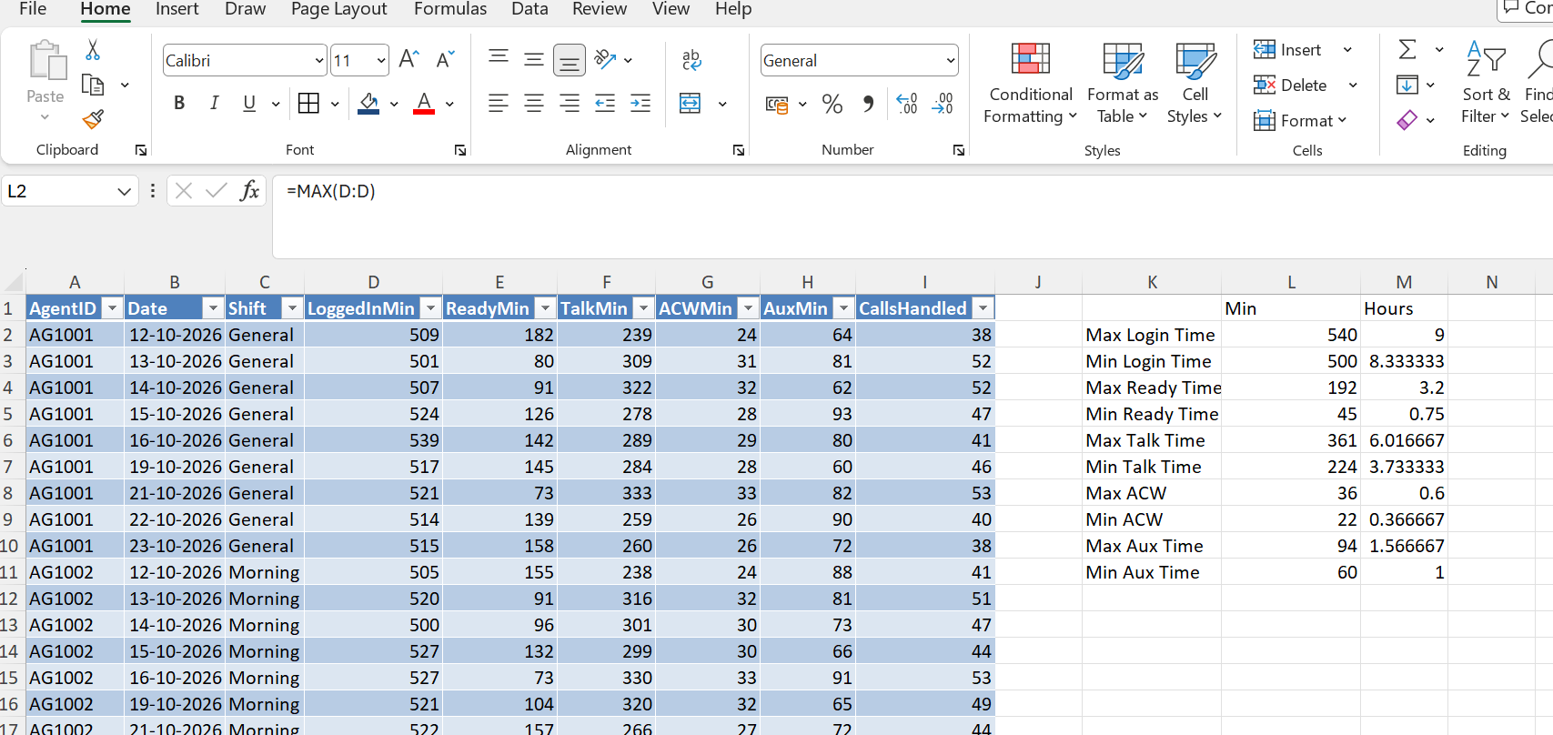

Step 2: Highlight the top and bottom values
Conditional formatting was applied LoggedInMin with Home > Conditional Formatting > Top/Bottom Rules: the top 5 values are shaded green and the bottom 5 are shaded red.
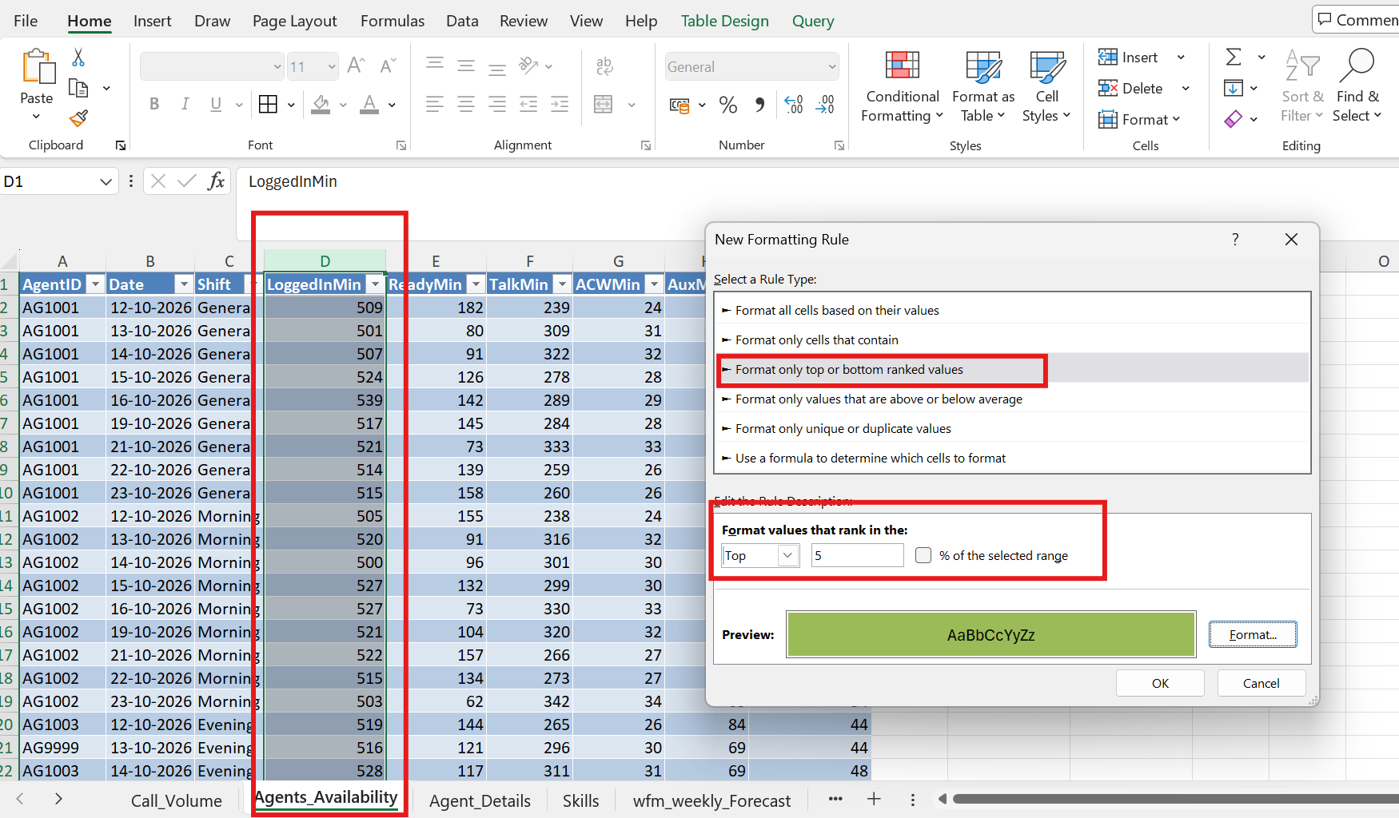
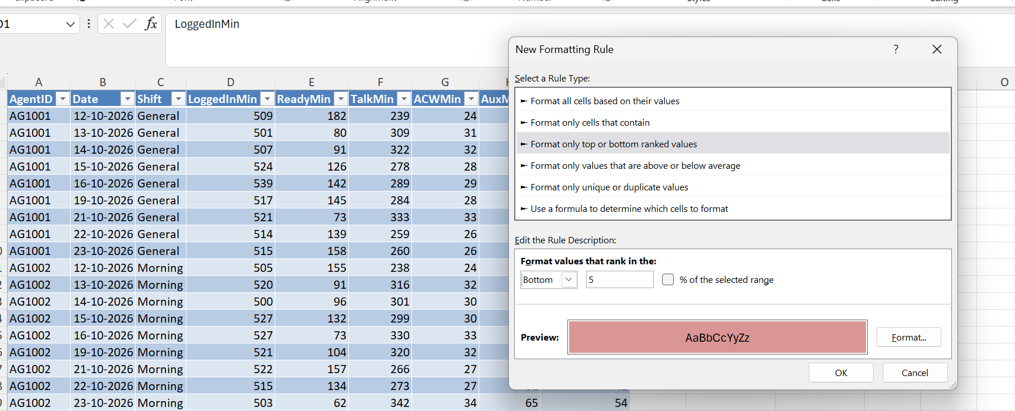

Step 3: Review with a PivotTable
A PivotTable was inserted with AgentID and Date in Rows and Average of LoggedInMin and Sum of ReadyMin in Values. To show login and ready time per agent view
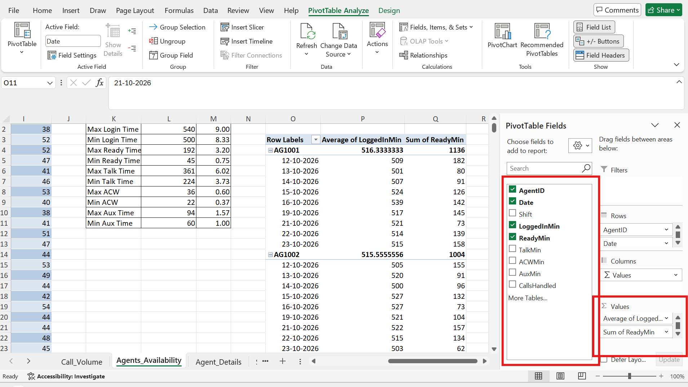
Figure 27: PivotTable summarising LoggedInMin and ReadyMin by agent and date

Step 4: Load into Power Query and find nulls and errors
Agent Availability table was loaded into Power Query . The Date column was typed as Any and contained a text date (22/10/2026), LoggedInMin showed an error marker and contained a null, and ReadyMin was stored as decimals.
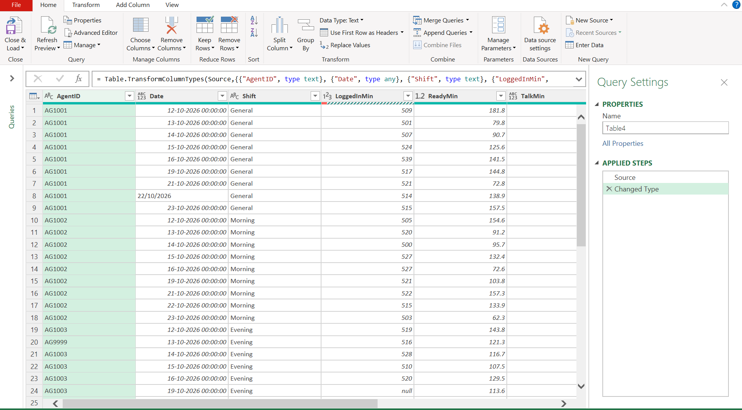

Step 5: Fix LoggedInMin
Filtering LoggedInMin for null returned 3 rows: AG1003 (19-10-2026), AG1005 (17-10-2026) and AG1015 (20-10-2026).

The applied steps were Changed Type > Removed Errors > Filtered Rows > Replaced Value > Sorted Rows > Replaced Value1. Sorting the column exposed a negative value, -504, which was replaced with 504 (the minus sign was a typing error). The average of the column was then calculated with Transform > Statistics > Average.

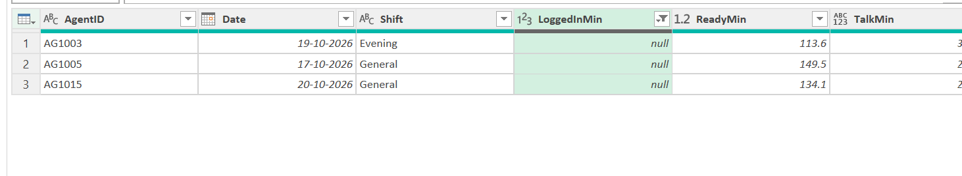
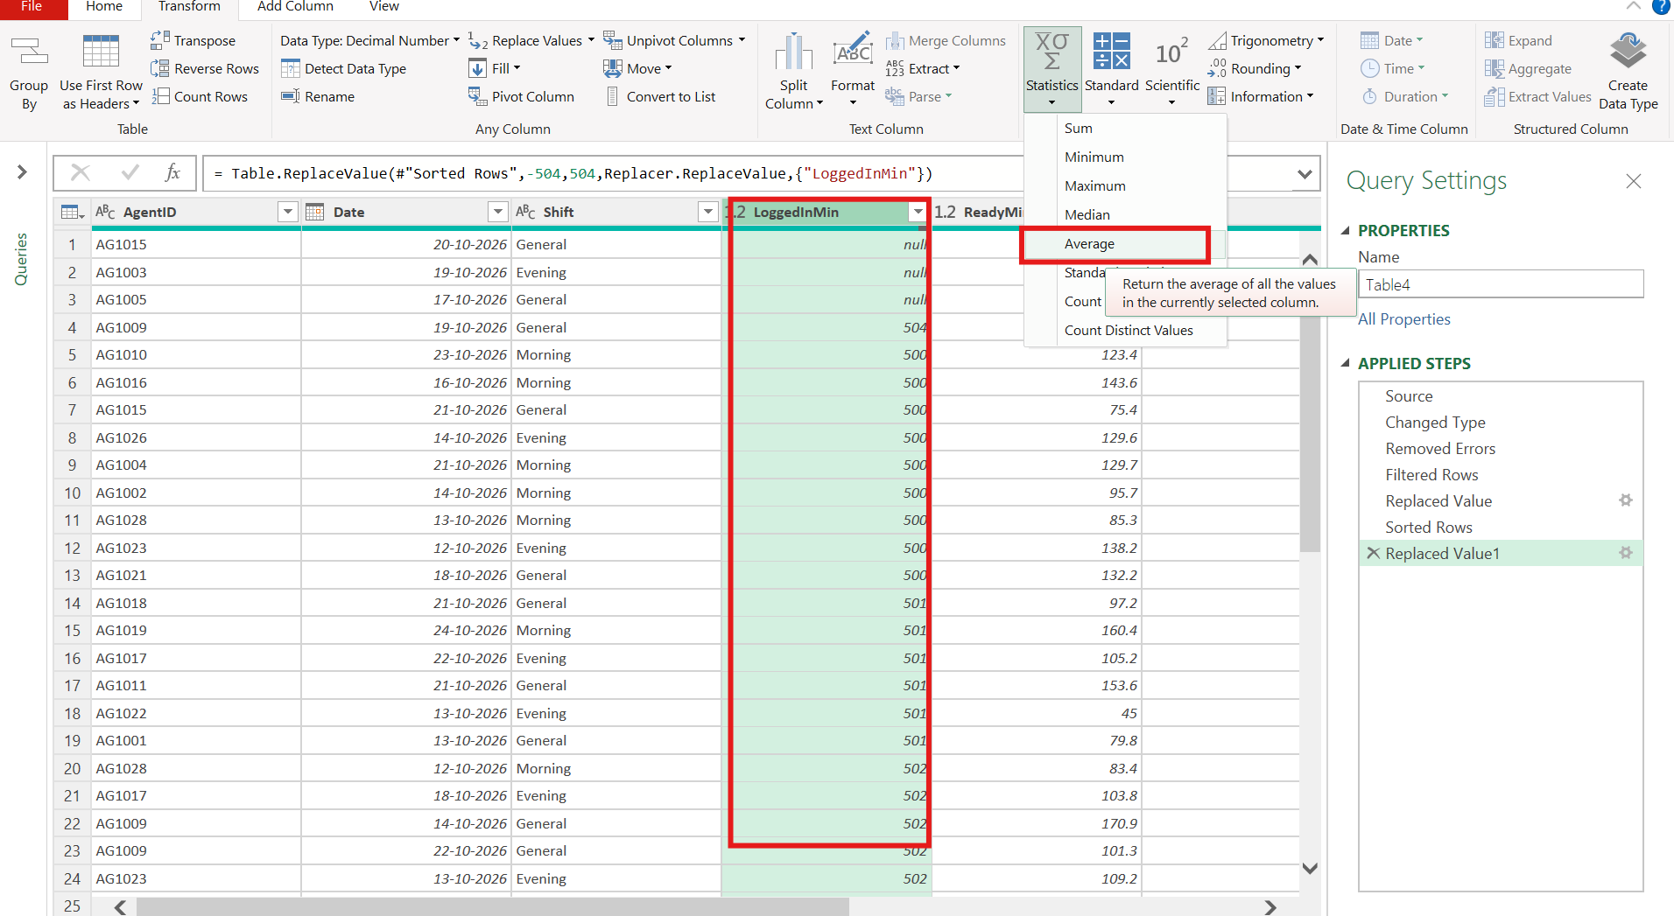

The average LoggedInMin was 537.36, so the three null values were replaced with 537.
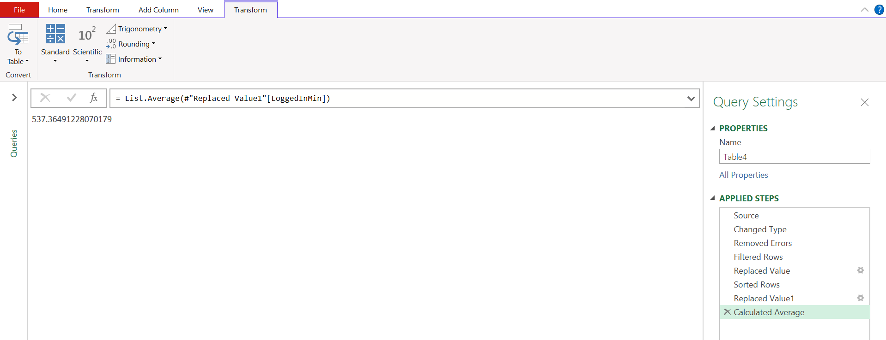
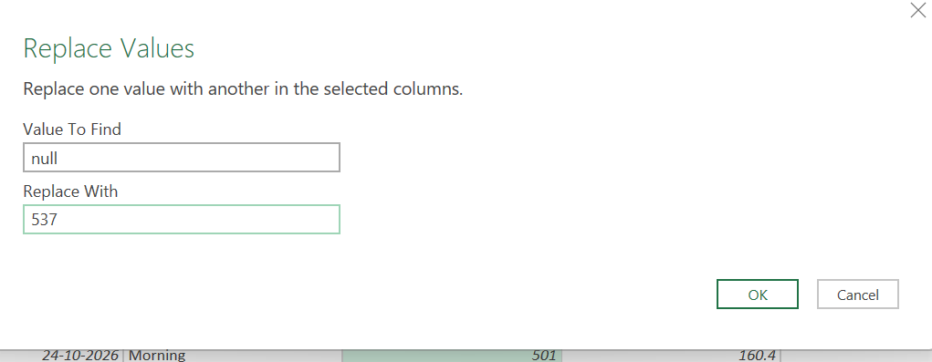

Step 6: Fix TalkMin
The TalkMin column was typed as text/Any because three rows contained the text "N/A". Filtering for "N/A" returned those 3 rows. The average of the valid TalkMin values was calculated (302.15) and used as the fill value, so the three entries now hold 302.
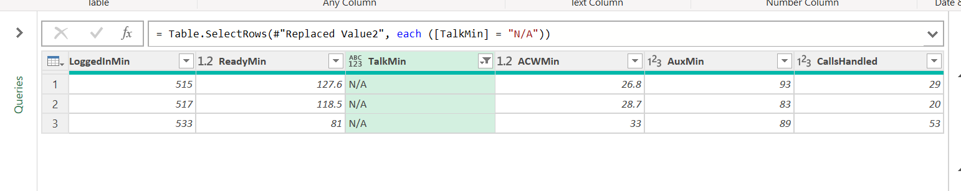
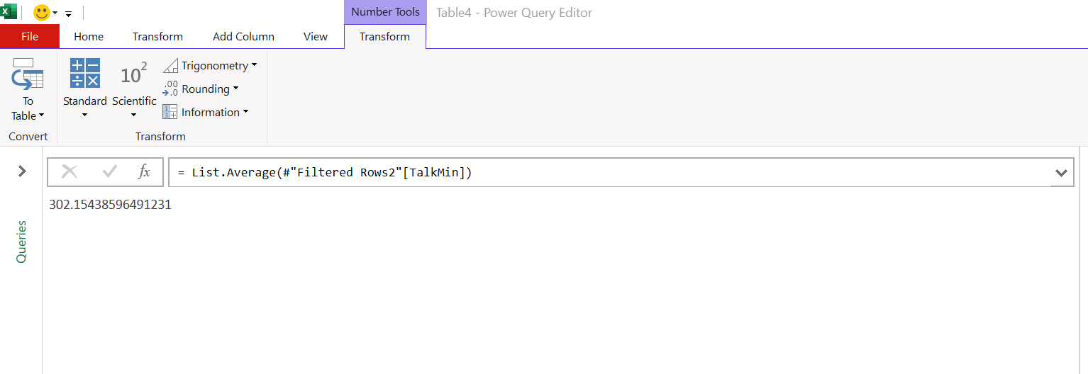

Step 7: Check CallsHandled
Errors in the CallsHandled column were removed (Removed Errors1 step) and the average of the column was calculated as 38.74 (about 39 calls) to use as the reference value for missing entries.
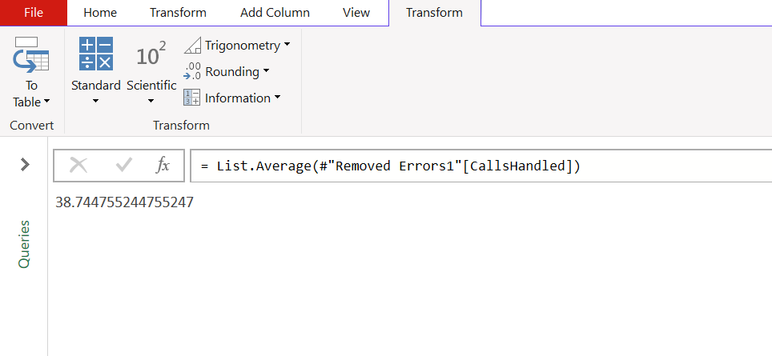

Step 8: Set the final data types
Finally the types were corrected: ReadyMin (which held decimals such as 181.8) to Whole Number so that all minute columns are consistent. The query ended with 9 columns and 284 rows and was loaded back to Excel with Close & Load.
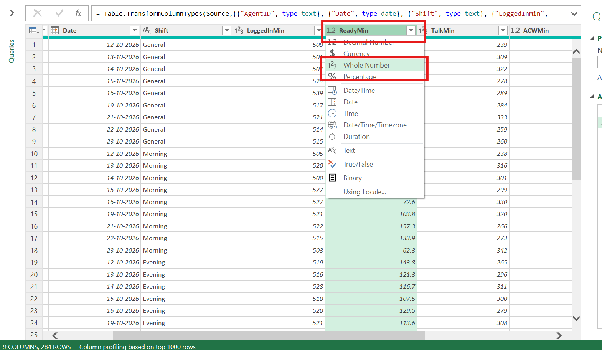

4. Agent_Details Sheet
This sheet lists the 30 agents with their name, primary skill, shift, site, team lead and hire date.

Step 1: Trim extra spaces
The table was loaded into Power Query. Some text had leading spaces (for example " Mohan Rao"), All text columns were selected and Transform > Format > Trim was applied to remove leading and trailing spaces.
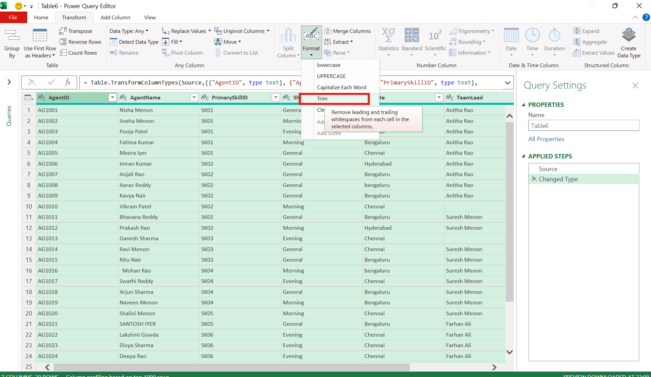

Step 2: Standardise capitalisation
Entries were in mixed case: "bengaluru" and "Bengaluru" in Site, and "SANTOSH IYER" in AgentName. Transform > Format > Capitalize Each Word (the Text.Proper function) was applied so that every value follows the same pattern, for example "Bengaluru" and "Santosh Iyer".
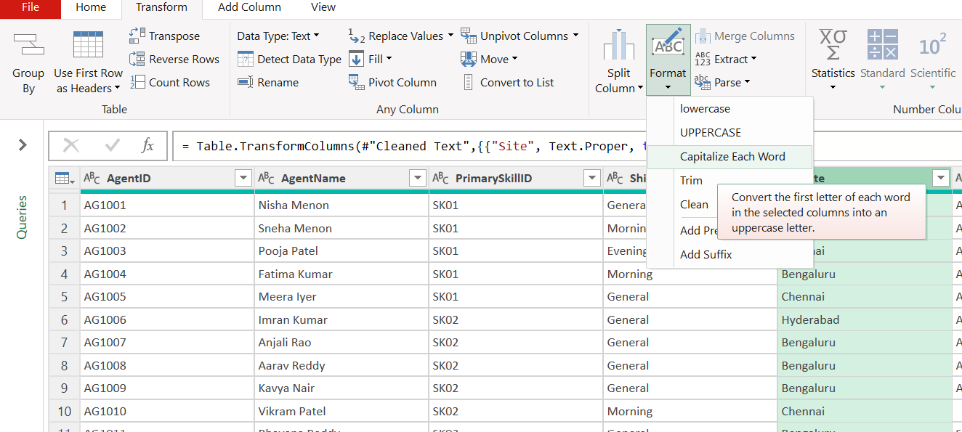

Step 3: Fill the missing TeamLead values
Filtering TeamLead for blanks returned 3 agents: AG1010 (SK02), AG1013 (SK03) and AG1030 (SK08).
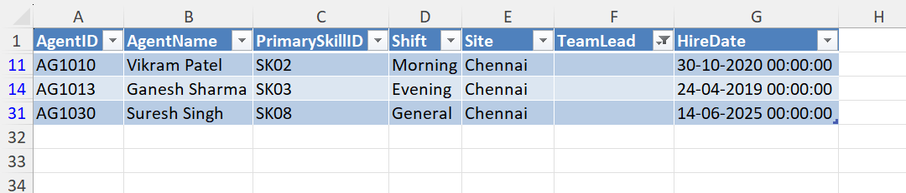
The table was then filtered by PrimarySkillID to see who leads each skill group. Each blank was filled with the team lead of the other agents on the same skill: AG1010 with Anitha Rao, AG1013 with Suresh Menon and AG1030 with Farhan Ali.
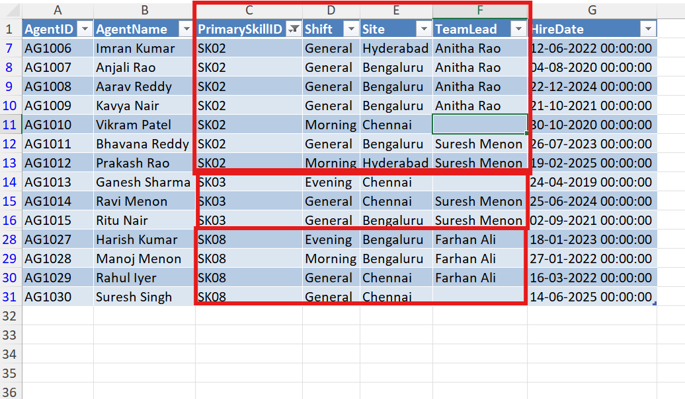

5. wfm_weekly_Forecast Sheet
This sheet holds the weekly workforce-management forecast for each skill: forecast calls, required agents, scheduled agents and shrinkage percentage.

Step 1: Review the table and create a PivotTable
The table (Table8) showed fractional agent counts such as 3.5 required and 3.7 scheduled agents, which are not realistic. A PivotTable was inserted from the table (Insert > PivotTable, placed on the same sheet and added to the Data Model) to work out reference averages used later.
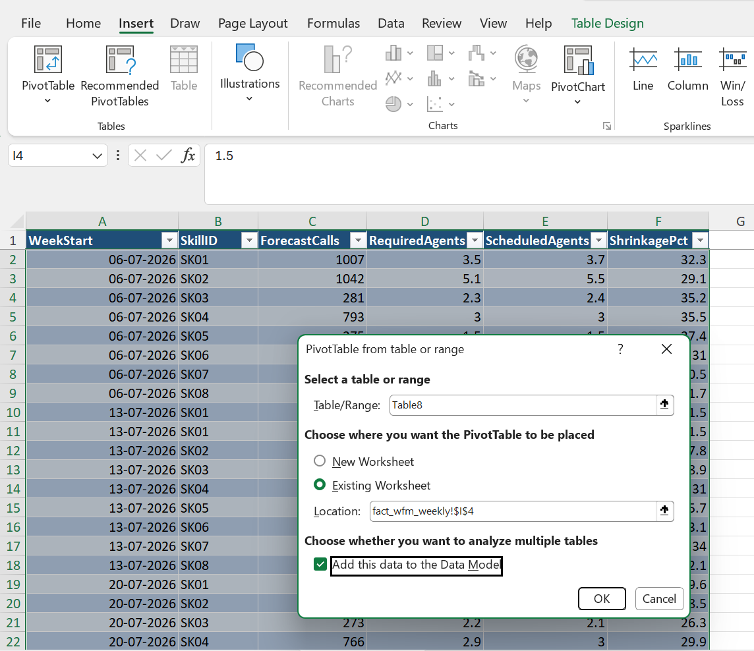

Step 2: Set data types and spot duplicates
In Power Query the WeekStart column was set to Date. Reviewing the rows revealed an exact duplicate (13-07-2026, SK01, 1,166 forecast calls appears twice). RequiredAgents and ScheduledAgents were converted to Whole Number.
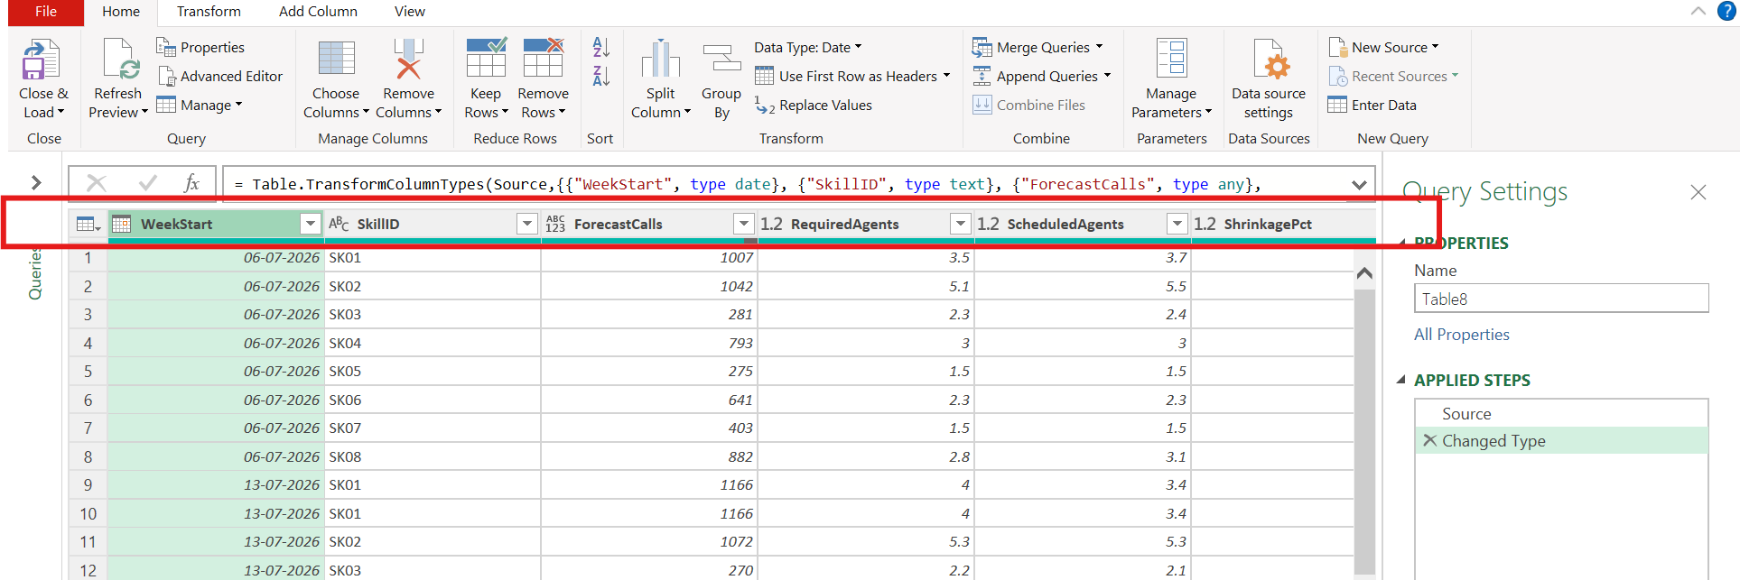

Step 3: Remove errors and duplicates
Remove Rows > Remove Errors and then Remove Duplicates were applied. The preview showed 130 rows before this step and the cleaned sheet holds 128 records.
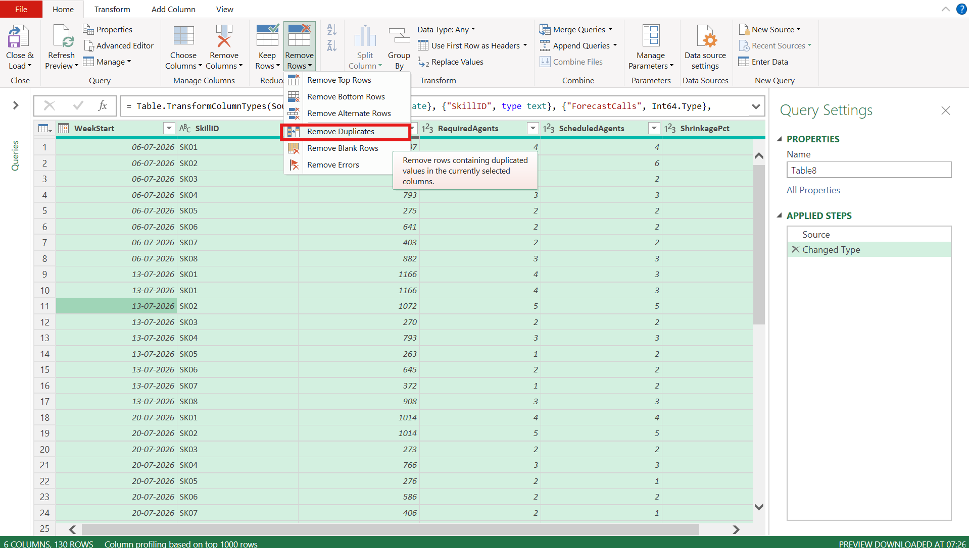
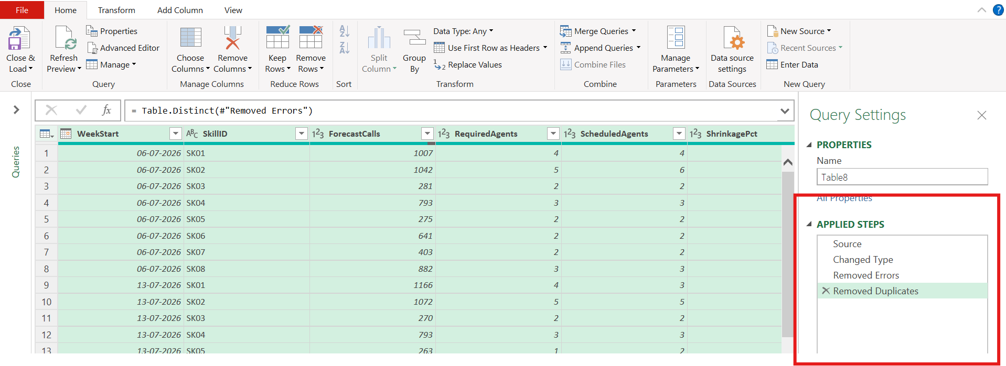

Step 4: Calculate the average call forecast per skill
Five rows had no call Forecast value. For filling the missing call Forecast value, The PivotTable was set up with SkillID in Rows and ForecastCalls in Values; the value field was changed from Sum to Average in Value Field Settings.
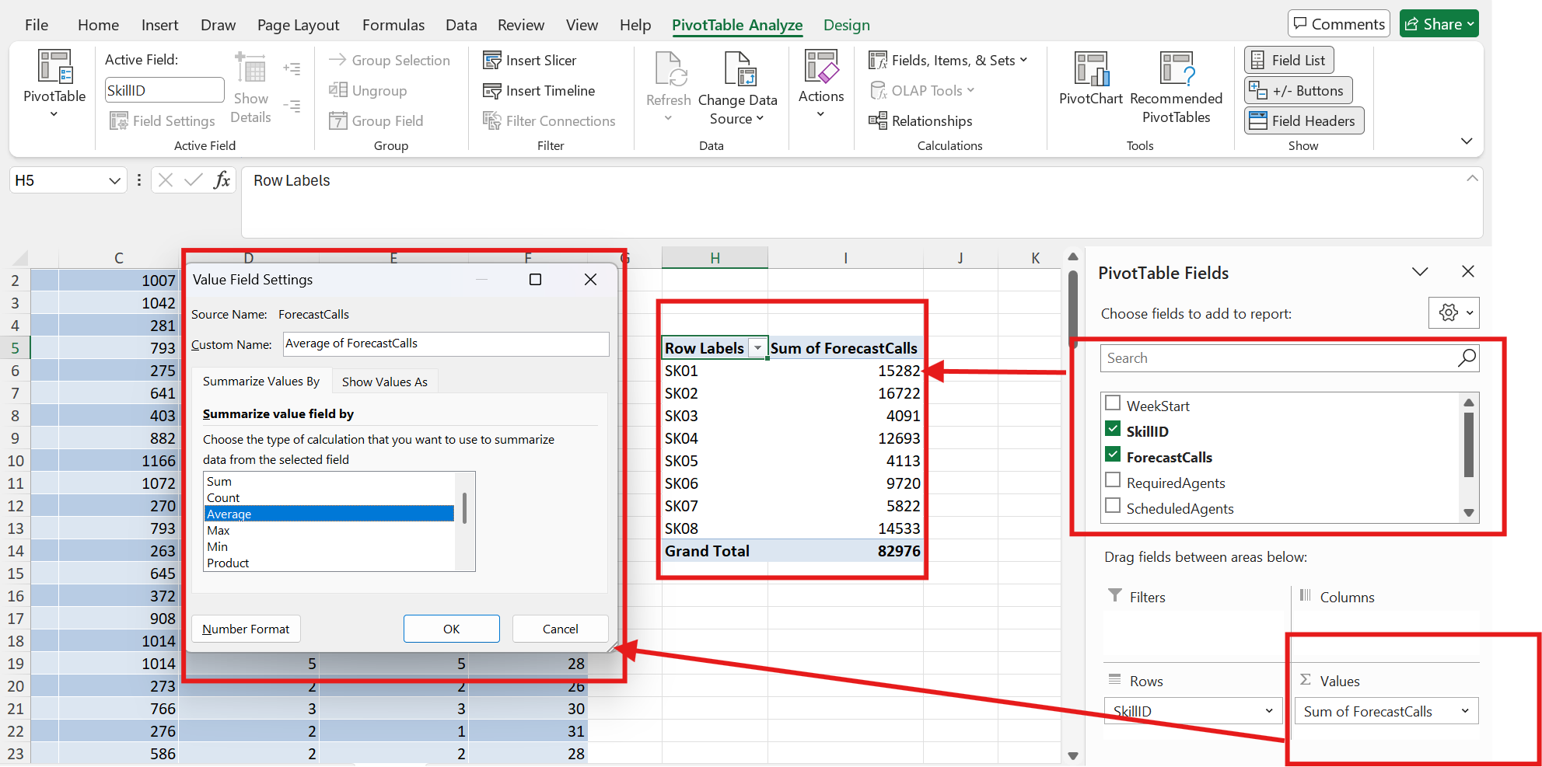
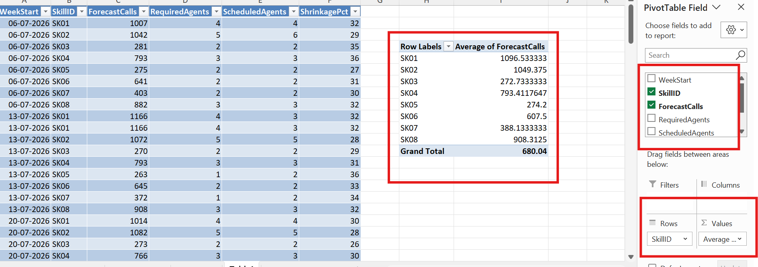

Filled the missing forecast values using the average values generated by the Pivot table for the skills

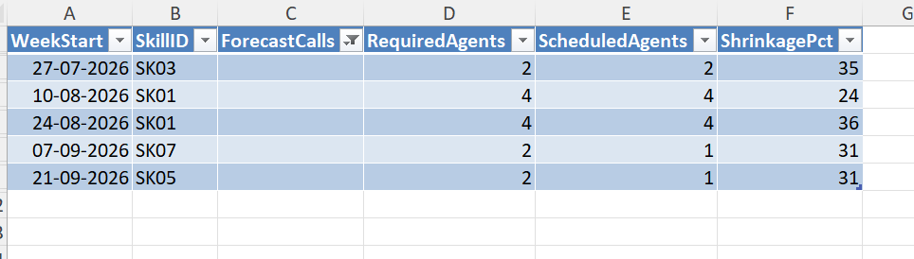
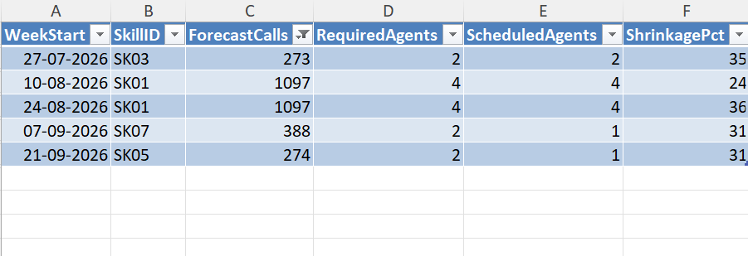

6. Leave Sheet
This sheet lists each leave taken by an agent with the date, the type of leave and the hours lost.

Step 1: Correct the AgentID
The table was loaded into Power Query. One AgentID was entered in lowercase (ag1027), so it would not match the same agent in other sheets. Replace Values was used to change it to AG1027.
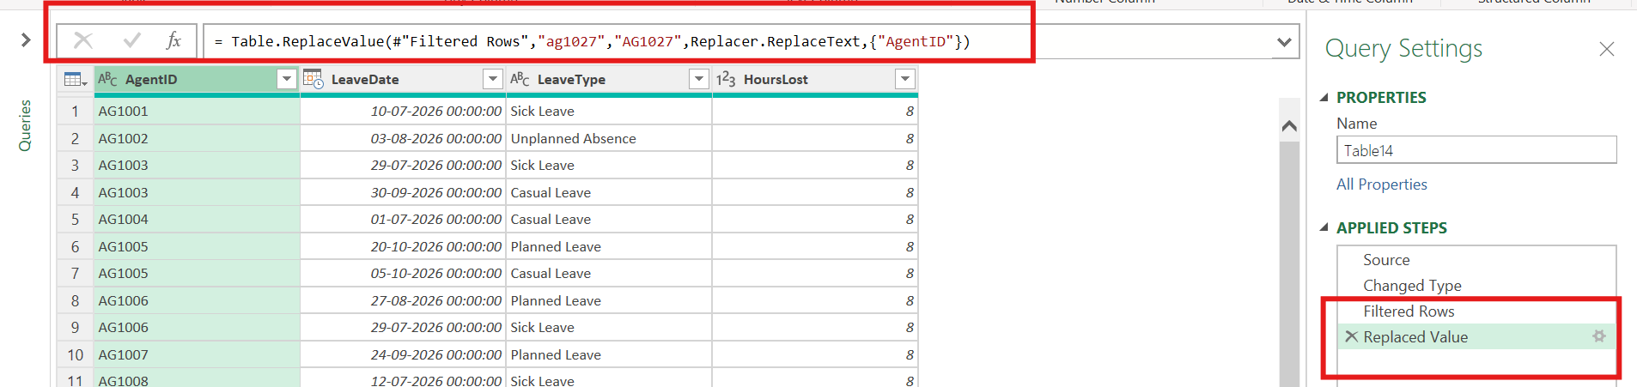

Step 2: Corrected the datatype of LeaveDate and correctly inconsistent values in LeaveType
The LeaveDate column was changed to the Date type. Filtering LeaveType showed the same category written in different ways: corrected the inconsistent values by Capitalizing each word,
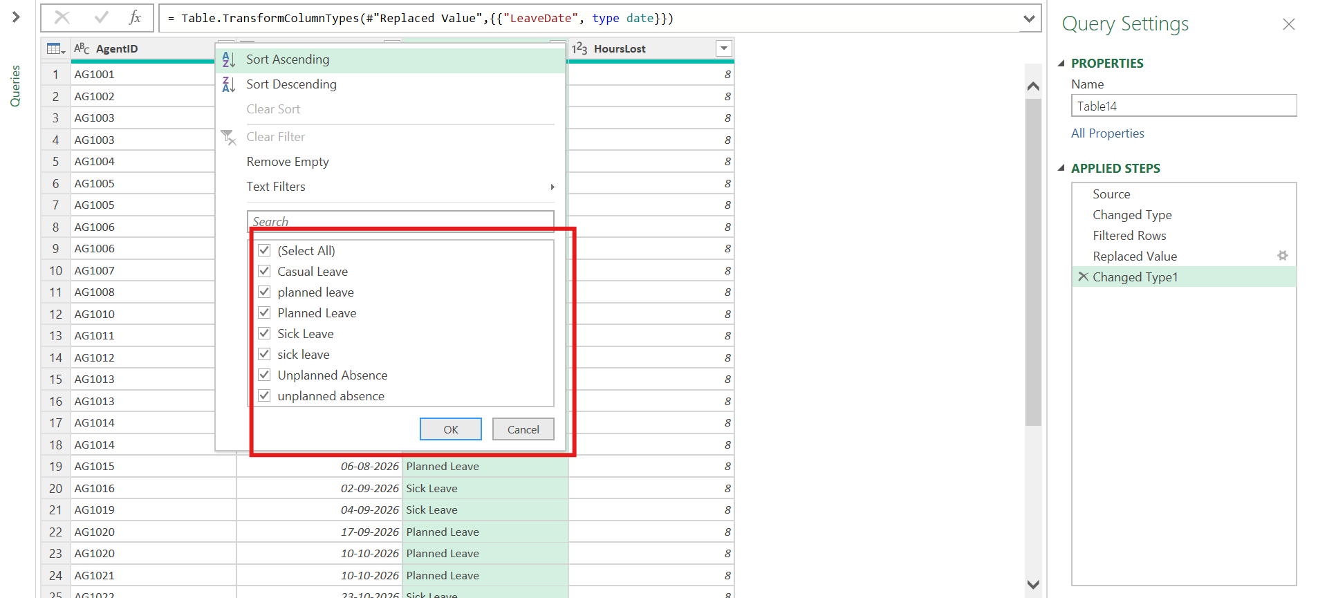

Transform > Format > Capitalize Each Word was applied to LeaveType. The filter list now shows only the four valid categories: Casual Leave, Planned Leave, Sick Leave and Unplanned Absence.
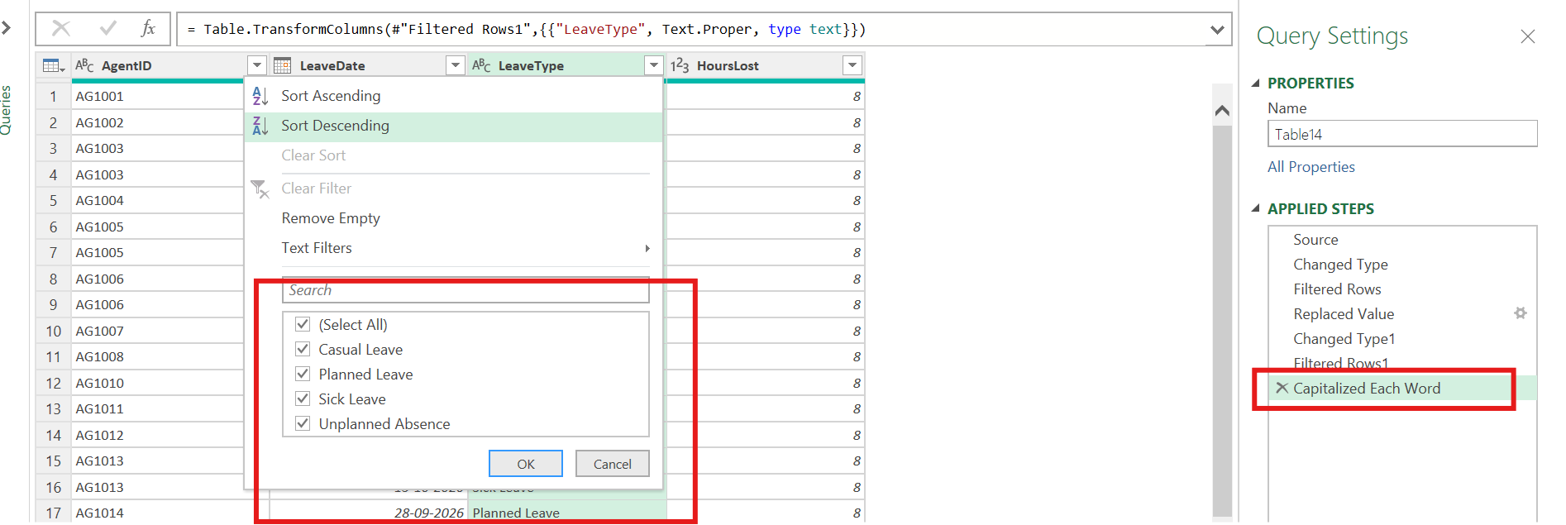

7. Calendar Sheet
The Calendar sheet lists every date from 01-07-2026 with its month, weekday and flags for weekends and holidays.

Step 1: Highlight weekends and holidays
Two conditional formatting rules applied on IsWeekend and IsHoliday columns, to highlight as green.
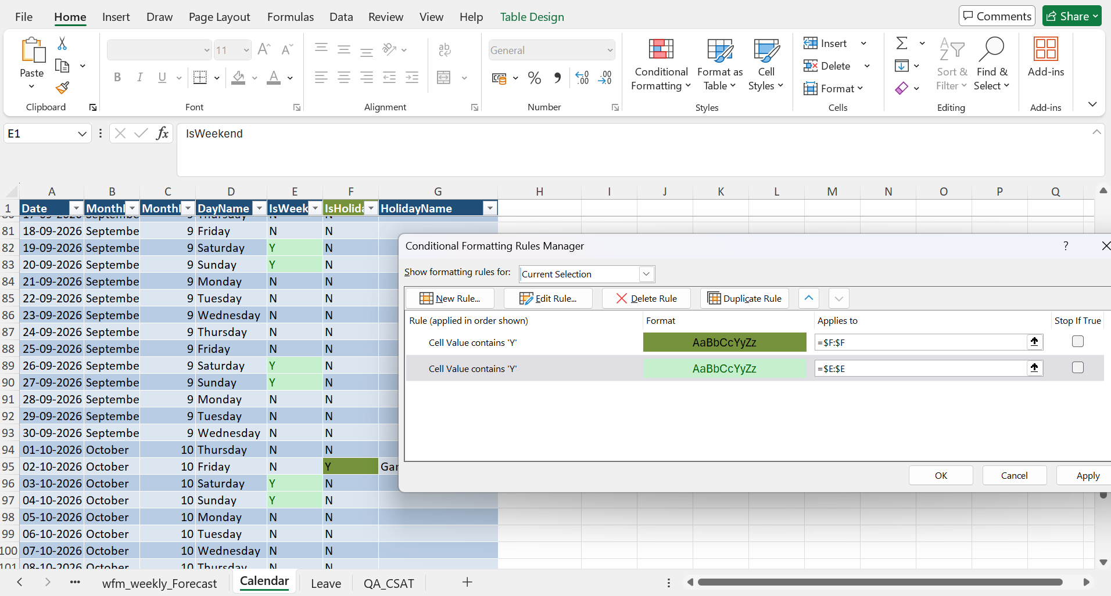

Step 2: Cross-check the day counts
A small summary table was built beside the calendar to check the no of days using below functions
- Working days: =NETWORKDAYS(A2,A118) = 83
- Weekends: =COUNTIF(Table25[IsWeekend],"Y") = 34
- Holidays: =COUNTA(Table25[HolidayName]) = 5
- Total Leaves: =SUM(K5,K6) = 39 (weekends plus holidays)
- Total Days: =COUNT(Table2[Date]) = 117
Working days (83) plus weekends (34) equal the 117 days in the calendar, so the weekend flags and the date list are consistent.
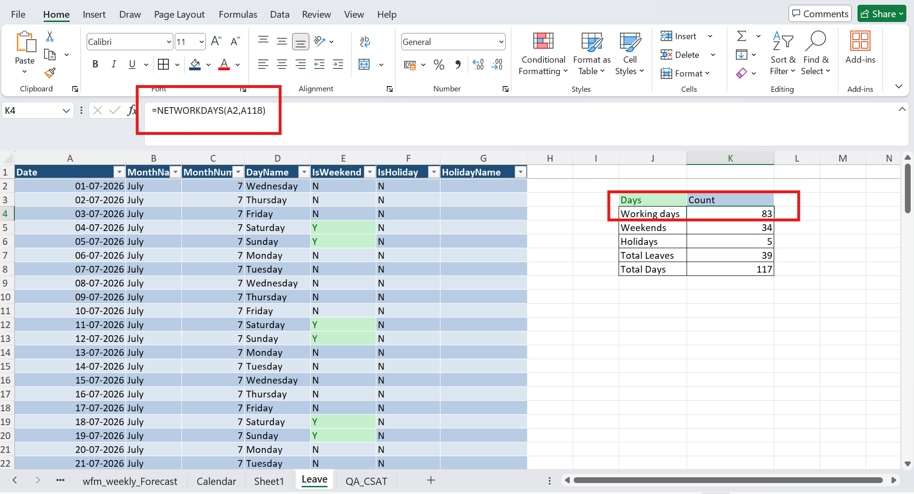
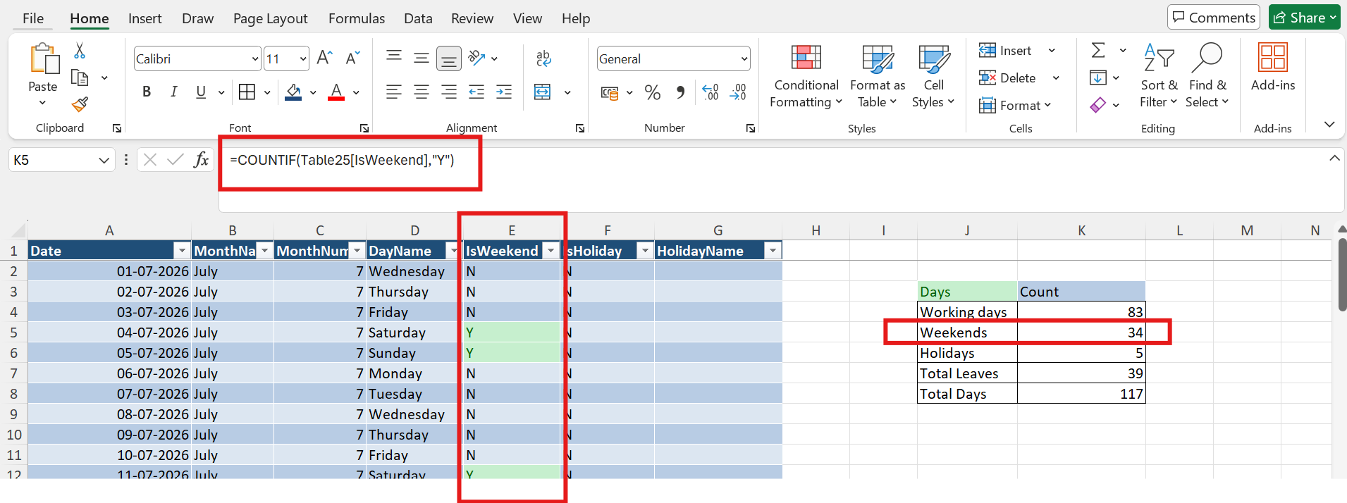
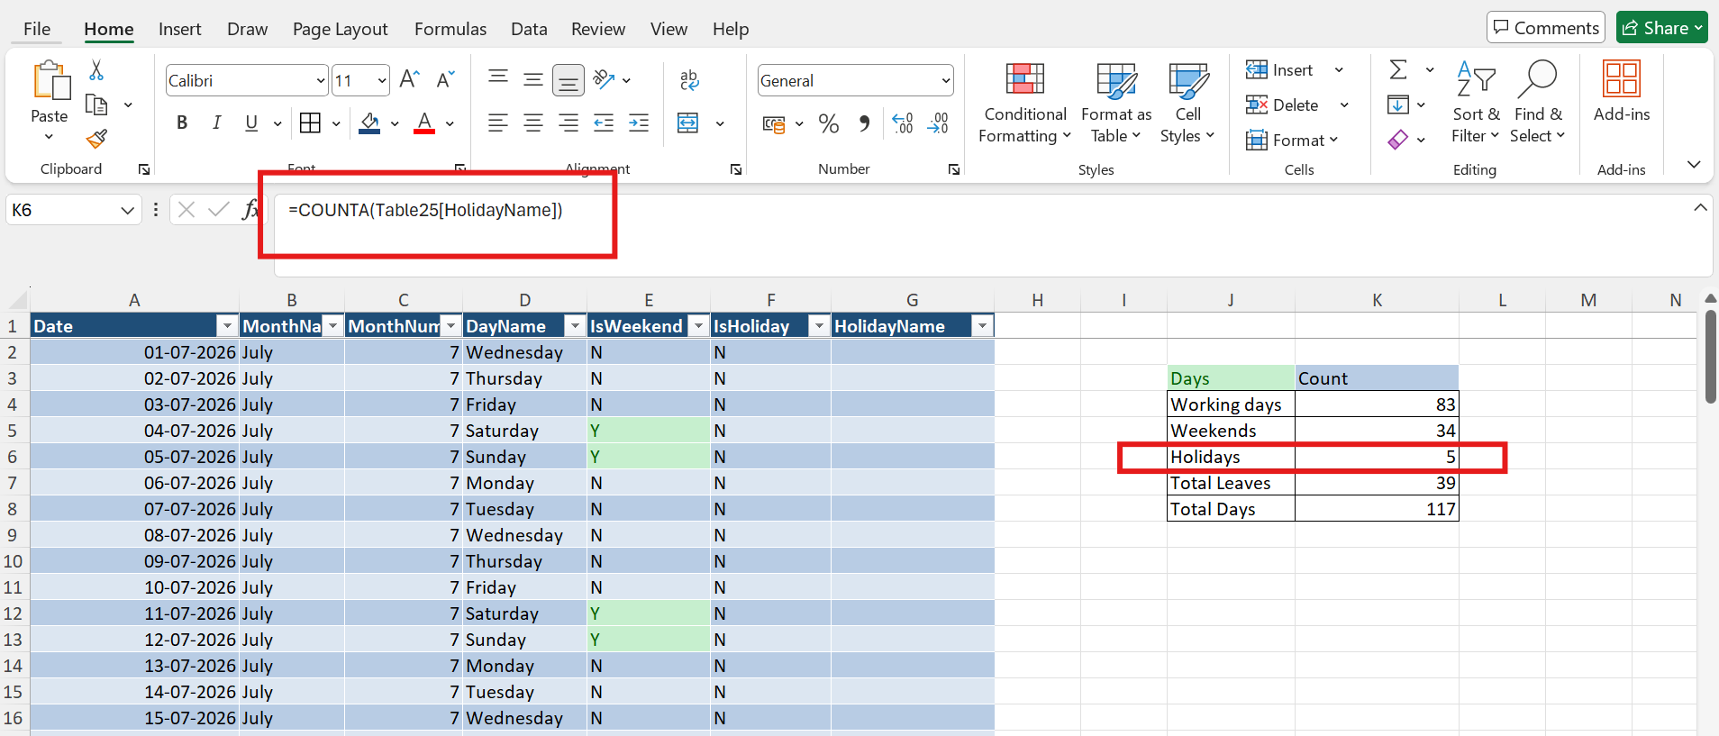
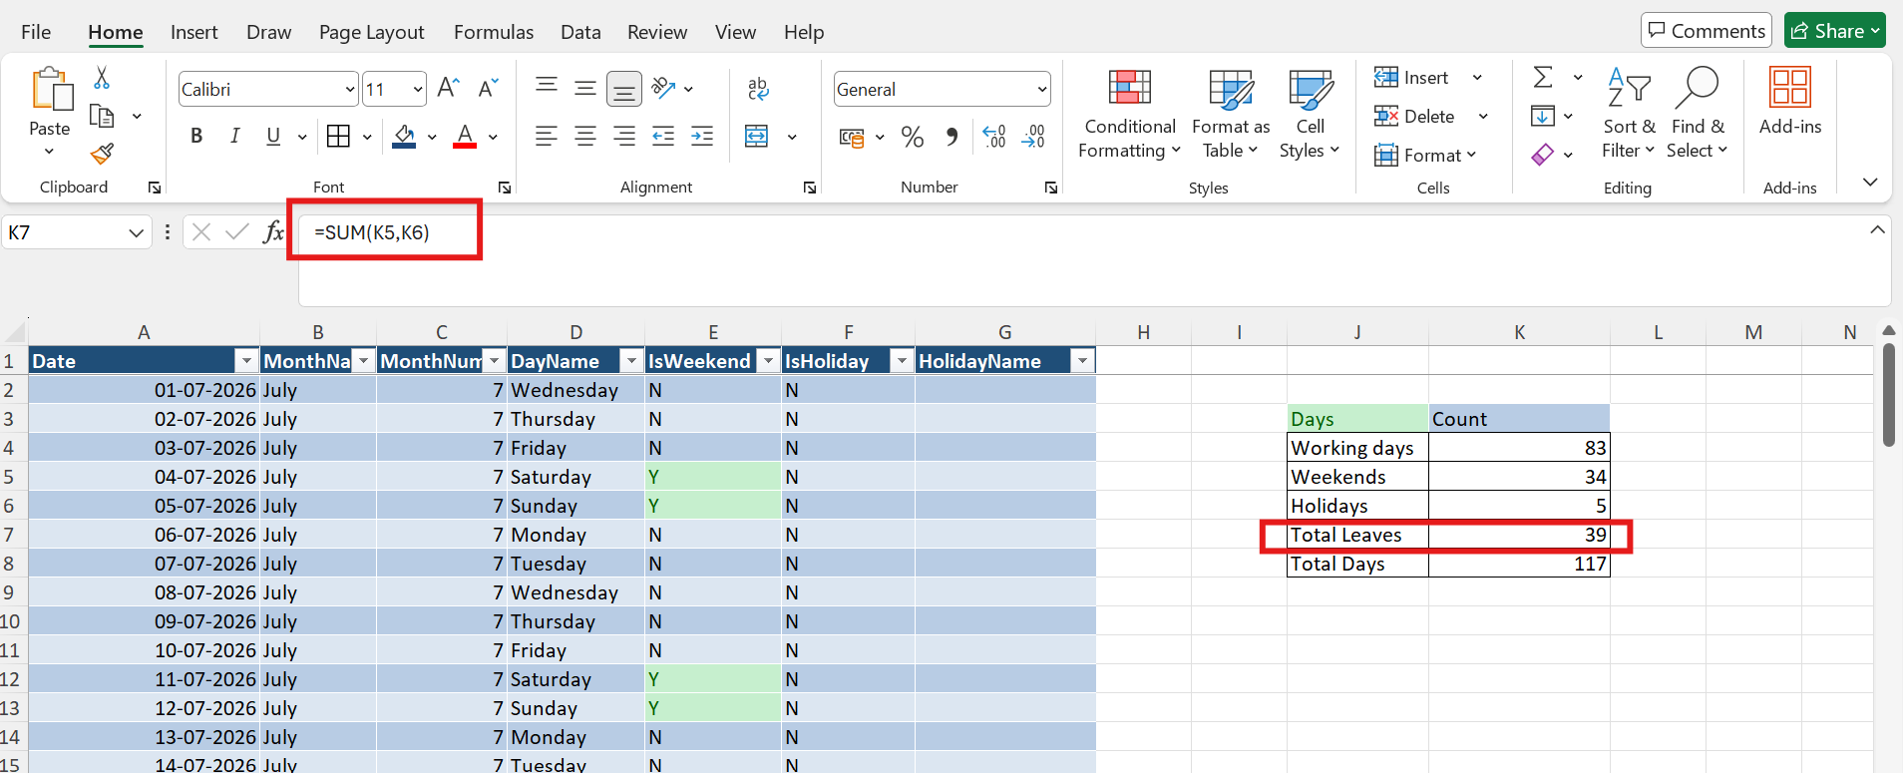
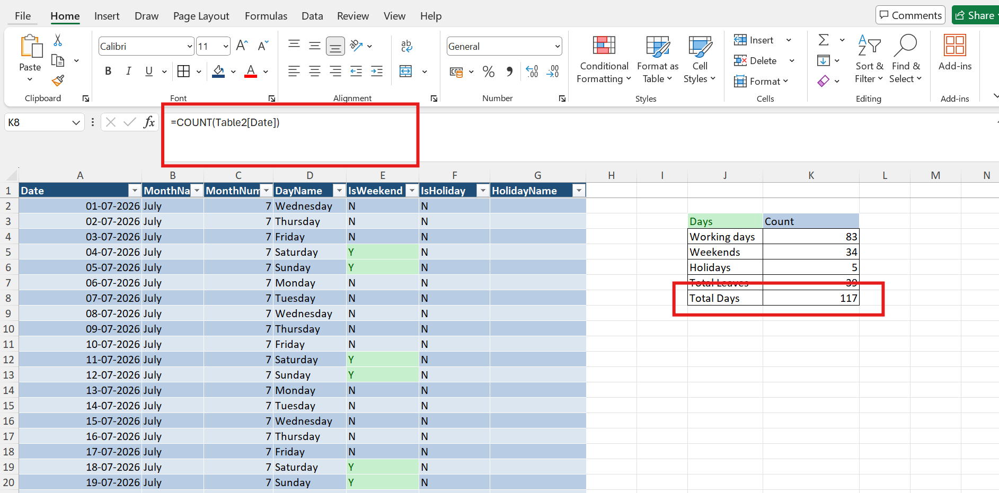

8. Result
After these steps the datasets have consistent data types, no duplicate rows, no null or "N/A" values in the cleaned columns, no impossible values in the call-volume and agent-time columns, and standardised text. The cleaned sheets are ready to be used for the visualization in Power BI.

